Question 2(a)
An appropriate system design pattern that can be adopted is the Observer pattern. The PurchaseProcessor is the Subject in this design, whereas WebPage is the Observer. The subject keeps a list of observers and informs them when there is any change in the system. Here, a purchase operation is completed with a database updated, and the PurchaseProcessor notifies its observers by invoking the notifyObservers() method. Every observer then calls its update() method in order to indicate the new state of the system.

This is the style which fits the system since the logic of purchasing and the webpage interface must be loosely coupled. The PurchaseProcessor need not contain the information of the mechanism of webpage refreshment and presentation. It can only interact with observers using the Observer interface. Such a separation of responsibilities makes the system easier to maintain and extend. As an example, an analytics module, some other analytics object, or other interface can be added without affecting the actual purchase processing logic.

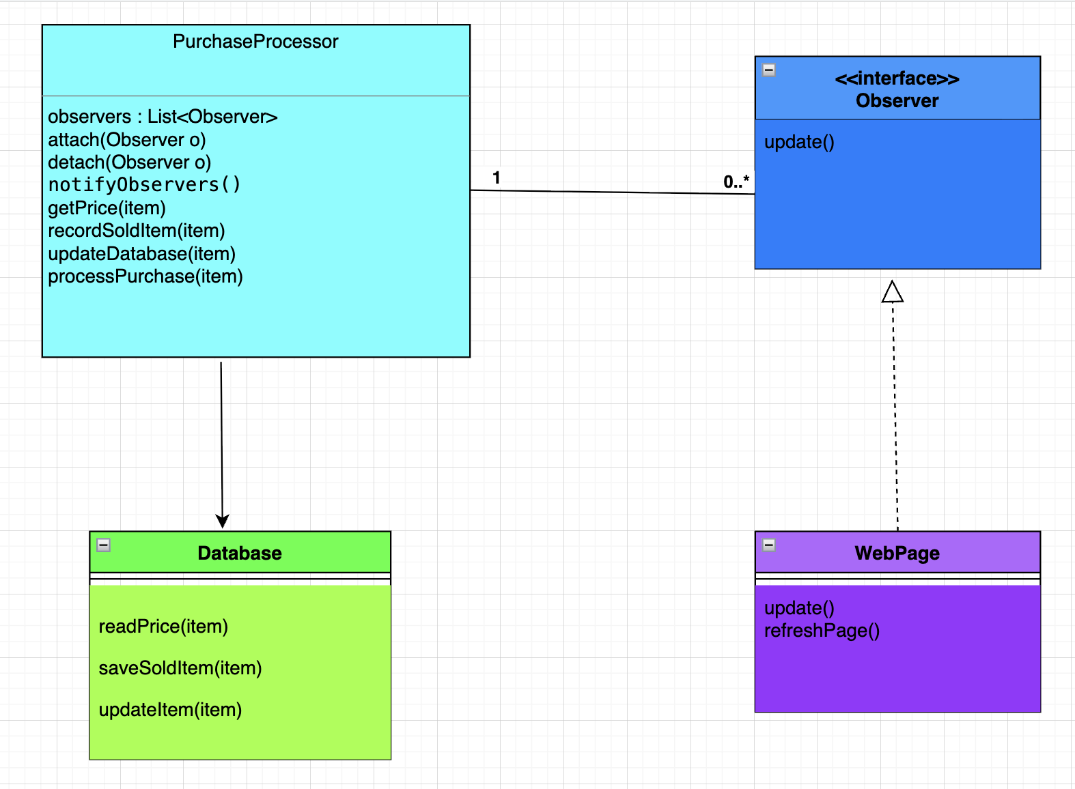

Question 2(b)

The Observer pattern enhances the maintainability of the system because it decreases the amount of dependency between the logic and the user interface of the purchase process. In this design, PurchaseProcessor uses the Observer interface to communicate with the observers, rather than directly referencing particular classes, like WebPage. Due to this abstraction, modification of the purchase processing logic is not necessary due to the revision of the webpage implementation.

Moreover, the system is made simpler to extend in case of the introduction of new components. As an example, a mobile application interface, notification service or monitoring tool that has to respond to purchase events can just implement the Observer interface and subscribe itself to the subject. The current classes need not be redesigned and rewritten.

The other strength is that the roles of the system are well defined. PurchaseProcessor is concerned with processing the purchase operation and with updating the database, and the observers are concerned with presentation or other response to the change. This isolation contributes to better code organization and simplifies the maintenance and modifications of the system over time.

Question 2(c)

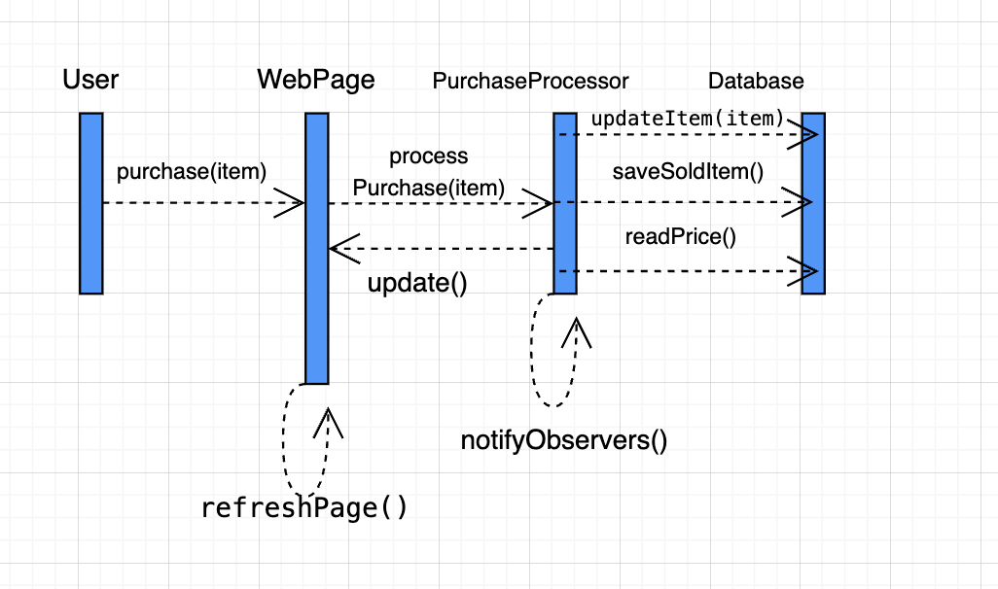
The sequence will start at the point of purchase, whereby the user carries out a purchase operation on the webpage. The request is relayed by the WebPage to the PurchaseProcessor through the processPurchase(item) method. PurchaseProcessor then provides communication to the Database to get the price of the item and update the purchase information stored. Once the database has been updated, the PurchaseProcessor calls notifyObservers of the change so that all the registered observers are notified of the change. The update parameter is passed to the WebPage, which subsequently updates the page by invoking the refresh page so that the user may view the updated information.

